**CSA0672 – DAA – DAY 2**

**G KRISHNA SAI**

**192011130**

**7. Write a program to generate all the reverse of a prime should be prime**

**( for example 907 is prime and reverse 709 is also prime )**

**Generate all the no’s upto N and estimate time complexity.**

**Program:**

#include<stdio.h> int main() { int c=0; int n,n1,f,i,j,k,r,p[100],f1; int sum=0,b=0,rev=0; c++; c++; c++; printf("Enter number:"); scanf("%d",&n); for(j=3;j<=n;j++)

{ c++; f=0; c++; for(i=2;i<j;i++)

{ c++; c++; if(j%i==0)

{

f=f+1; c++;

} } c++; c++; if(f==0) { n1=j; c++; rev=0; c++; while (n1!=0)

{ c++; r=n1%10; c++; rev=(rev*10)+r; c++; n1=n1/10; c++;

} c++; f1=0; c++; for(k=2;k<rev;k++)

{ c++; c++; if(rev%k==0)

{ f1++; c++;

}

}

c++; c++; if(f1==0)

{ printf("%d\n",j);

}

} } c++; printf("Time Complexity : %d",c); }

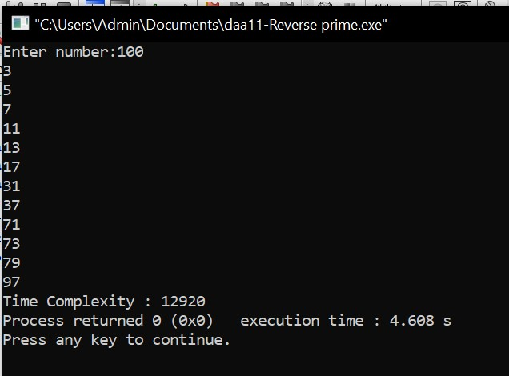

**8. Compute the program to find the GCD of two numbers. And also find the finf of time Recursion used to estimate time complexity.**

**Program:**

#include<stdio.h> int main() { int c=0; int a,b,af[100],bf[100],cf[100],a1,b1,c1,i,j,g; printf("Enter 1st number : "); scanf("%d",&a); printf("Enter 2nd number : "); scanf("%d",&b); a1=-1; c++; for(i=1;i<=a;i++)

{ c++; c++; if(a%i==0)

{ a1=a1+1; c++; af[a1]=i; c++;

}

} c++; b1=-1; c++; for(i=1;i<=b;i++)

{

c++; c++; if(b%i==0)

{

b1=b1+1; c++; bf[b1]=i; c++;

} } c++; c1=-1; c++; for(i=0;i<a1+1;i++)

{ c++; for(j=0;j<b1+1;j++)

{ c++; c++; if(af[i]==bf[j]) { g=af[i]; c++;

} } c++; } c++; printf("GCD : %d\n",g); printf("Time Complexity : %d",c); }

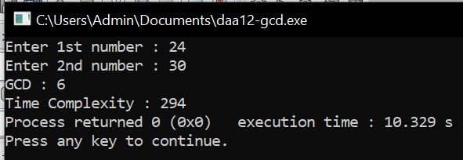

**9. Generate a program for Pascal triangle.**

**Estimate the time complexity for the row=5**

**1**

**1 1**

**1 2 1**

**1 3 3 1 1 4 6 4 1**

**Program:**

#include<stdio.h> int main() { int c=0; int n,i,j,k,s,c1; printf("Enter no of rows :"); scanf("%d",&n); k=n; c++; for(i=0;i<n;i++)

{ c++; k=k-1; c++; for(s=0;s<k;s++)

{ c++; printf(" ");

} c++; for(j=0;j<=i;j++)

{

c++; c++; if(j==0)

{ c1=1; c++;

} else

{ c1=c1*(i-j+1)/j; c++;

} printf("%d ",c1);

} c++; printf("\n");

} c++; printf("Time Complexity : %d",c); }

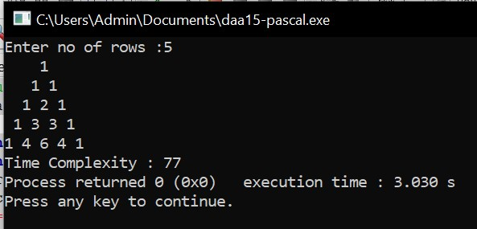

**10. Write a program to find the largest element value in an array. Estimate the time complexity and no of comparison for the given set of values.**

**Program:**

#include<stdio.h> int main() { int c=0; int com=0,i,j,k,a[100],n; c++; printf("Enter no of elements:"); scanf("%d",&n); printf("Enter elements :\n"); for(i=0;i<n;i++)

{ c++; scanf("%d",&a[i]);

} c++; for(i=0;i<n;i++)

{ c++; for(j=0;j<n;j++)

{ c++; com++; c++; c++; if(a[i]>a[j])

{ k=a[i]; c++; a[i]=a[j]; c++; a[j]=k; c++;

} } c++; } c++; printf("Largest value : %d\n",a[0]); printf("Comparisions : %d\n",com); printf("Time complexity : %d\n",c); }

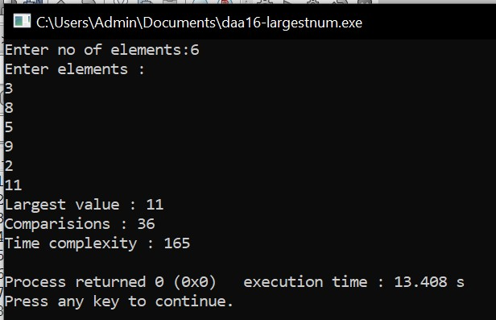

**11. Write a program to find the factorial (fact)of a number and to estimate time complexity.**

**Condition such as i. n=0, return 1 otherwise fact (n-1) * n Program:**

#include<stdio.h> int fact(int n); int c=0; int main() { int n; printf("Enter Number : "); scanf("%d",&n); fact(n); printf("Factorial : %d\n",fact(n)); printf("Time Complexity : %d\n",c); return 0;

} int fact(int n)

{

int f; c++; if(n<=1)

{ f= 1; c++;

} else {

f= n*fact(n-1); c++;

}

return f;

}

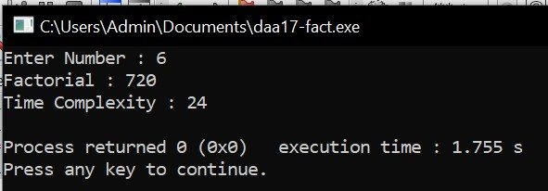

**12. Write a program to print the first n perfect numbers. (Hint**

**Perfect number means a positive integer that is equal to the sum of its proper divisors) Sample Input:**

**N = 3**

**Sample Output:**

**First 3 perfect numbers are: 6 , 28 , 496 Test Cases:**

1. **N = 0**
2. **N = 5**
3. **N = -2**
4. **N = -5**

**N = 0.2**

**Program:**

#include<stdio.h> int main() { int c=0;

int i,j,sum,n,a[20],k=0; c++; printf("Enter N:"); scanf("%d",&n); c++; if(n<1) { printf("Invalid Input");

}

else

{

for(i=6;i<10000;i++)

{ c++; sum=0; c++; for(j=1;j<i-1;j++)

{ c++; c++; if(i%j==0)

{

sum=sum+j; c++;

} } c++; c++; if(i==sum)

{ a[k++]=i; c++;

} }c++; for (i=0;i<n;i++)

{ c++; printf("%d\n",a[i]);

}c++;

}

printf("Time Complexity : %d",c); }

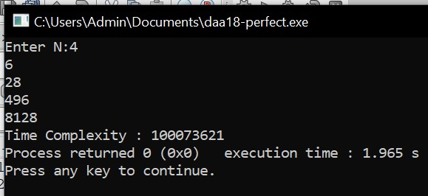

**13. Write a C program to check whether is a given input is a palindrome Program:**

#include<stdio.h> int main() { int c=0; int n,r,rev=0,a; c++; printf("Enter number:"); scanf("%d",&n); a=n; c++; while (n!=0)

{ c++; r=n%10; c++; rev=(rev*10)+r; c++; n=n/10; c++;

} c++; c++; if(rev==a)

{

printf("Palindrome Number");

} else { printf("Not Palindrome Number");

}

printf("\nTime Complexity : %d\n",c); }

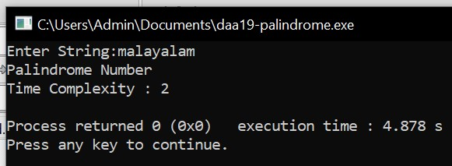

**14. Write a program to perform Bubble sort and estimate time Complexity Program:**

#include<stdio.h> int main() { int c=0; int com=0,i,j,k,a[100],n; c++; printf("Enter no of elements:"); scanf("%d",&n); printf("Enter elements :\n"); for(i=0;i<n;i++)

{ c++; scanf("%d",&a[i]);

} c++; for(i=0;i<n;i++)

{ c++; for(j=0;j<n;j++)

{ c++; com++; c++; c++; if(a[i]<a[j])

{ k=a[i]; c++; a[i]=a[j]; c++; a[j]=k; c++;

} } c++; } c++; printf("Bubble Sort :\n"); for(i=0;i<n;i++)

{ c++; printf("%d\n",a[i]);

} c++; printf("Time complexity : %d\n",c);

}

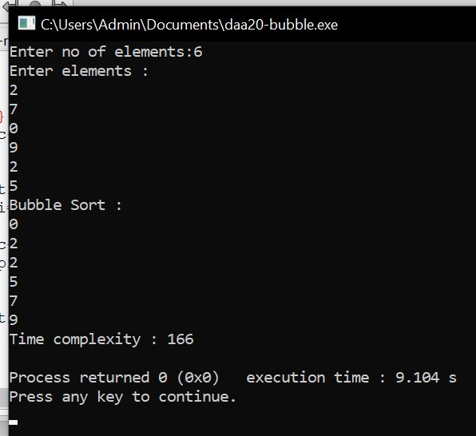

**15. Write a program to print the reverse of a string. And estimate the time complexity Program:**

#include<stdio.h> int main()

{ int c=0,l,i; char s[20]; printf("Enter String:"); scanf("%s",&s); l=strlen(s); c++; printf("Reverse String : "); for(i=l-1;i>-1;i--)

{ c++; printf("%c",s[i]);

} c++;

printf("\nTime Complexity : %d\n",c); }

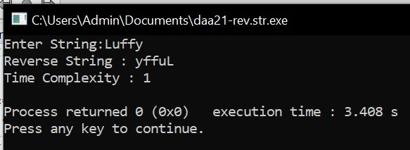

**16. Write a program to check sub string is there in a string or not.**

**Program:**

#include<stdio.h> int main() { int c=0,l1,l2,i,cnt=0; char s[100],sub[20],os[20],at='@',sub1[20]; c++; printf("Enter String:"); scanf("%s",&s); printf("Enter Sub String:"); scanf("%s",&sub); l1=strlen(s); c++; l2=strlen(sub); c++; strncat(sub,&at,1); c++; for(i=0;i<=l1+1-l2;i++)

{ c++; strncpy(os,s+i,l2); c++; c++; if(strcmp(sub,os)==0)

{ cnt++; c++;

} } c++; printf("Count : %d",cnt); printf("\nTime Complexity : %d\n",c);

}

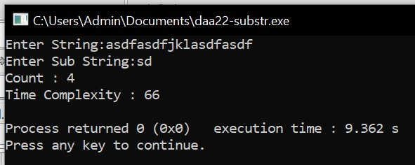

**1. Write a C program to merge sort using divide and Conquer Program:**

#include<stdio.h> void mergesort(int a[],int i,int j); void merge(int a[],int i1,int j1,int i2,int j2); int main() { int a[30],n,i; printf("Enter no of elements:"); scanf("%d",&n); printf("Enter array elements:\n"); for(i=0;i<n;i++)

{ scanf("%d",&a[i]);

} mergesort(a,0,n-1); printf("Merge Sort : \n"); for(i=0;i<n;i++)

{ printf("%d\n",a[i]);

} return 0;

}

void mergesort(int a[],int i,int j)

{ int mid; if(i<j) { mid=(i+j)/2; mergesort(a,i,mid); mergesort(a,mid+1,j); merge(a,i,mid,mid+1,j);

}

} void merge(int a[],int i1,int j1,int i2,int j2)

{ int temp[50]; int i,j,k; i=i1; j=i2; k=0; while(i<=j1 && j<=j2)

{ if(a[i]<a[j])

{

temp[k++]=a[i++];

} else

{

temp[k++]=a[j++];

}

}

while(i<=j1)

{

temp[k++]=a[i++];

}

while(j<=j2)

{

temp[k++]=a[j++];

}

for(i=i1,j=0;i<=j2;i++,j++)

{ a[i]=temp[j];

}

}

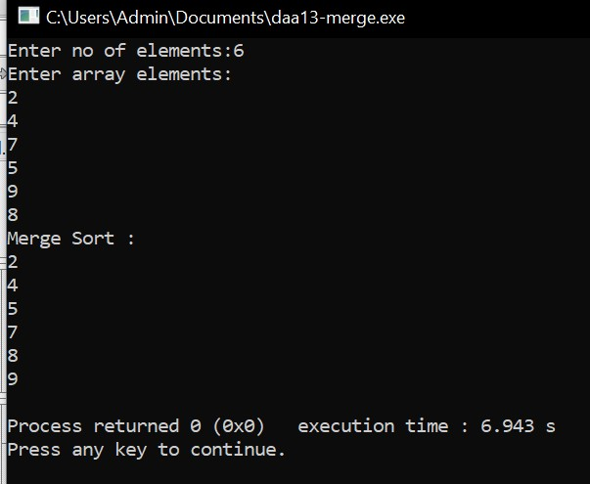

**2. Write a C program to find max-min using divide and**

**Conquer Program:**

#include<stdio.h> void mergesort(int a[],int i,int j); void merge(int a[],int i1,int j1,int i2,int j2);

int main() {

int a[30],n,i;

printf("Enter no of elements:"); scanf("%d",&n);

printf("Enter array elements:\n"); for(i=0;i<n;i++)

{

scanf("%d",&a[i]);

}

mergesort(a,0,n-1); printf("\nMin : %d",a[0]); printf("\nMax : %d",a[n-1]);

return 0;

}

void mergesort(int a[],int i,int j)

{ int mid; if(i<j) { mid=(i+j)/2; mergesort(a,i,mid); mergesort(a,mid+1,j);

merge(a,i,mid,mid+1,j);

}

}

void merge(int a[],int i1,int j1,int i2,int j2)

{ int temp[50]; int i,j,k; i=i1; j=i2;

k=0;

while(i<=j1 && j<=j2)

{

if(a[i]<a[j])

{

temp[k++]=a[i++];

} else

{

temp[k++]=a[j++];

}

}

while(i<=j1)

{

temp[k++]=a[i++];

}

while(j<=j2)

{

temp[k++]=a[j++];

}

for(i=i1,j=0;i<=j2;i++,j++)

{

a[i]=temp[j];

}

}

